Neural network:

Code:

# -*- coding: utf-8 -*-

"""

Created on Thu Nov 19 12:53:00 2020

@author: sunil

"""

from keras.models import Sequential

from keras.layers import Dense

import numpy

import pandas as pd

from sklearn import preprocessing

seed = 8

numpy.random.seed(seed)

# load pima indians dataset

dataset = numpy.loadtxt("ff.csv", delimiter=",")

# split into input (X) and output (Y) variables

X = dataset[:,0:7]

Y = dataset[:,7]

model = Sequential()

model.add(Dense(12, input_dim=8, activation='relu'))

model.add(Dense(8, activation='relu'))

model.add(Dense(1, activation='sigmoid'))

model.summary()

model.compile(loss='binary_crossentropy', optimizer='adam', metrics=['accuracy'])

model.fit(X, Y, validation_split=0.33, epochs=150, batch_size=50)

scores = model.evaluate(X, Y)

print("%s: %.2f%%" % (model.metrics_names[1], scores[1]*100))

model.history.history.keys()

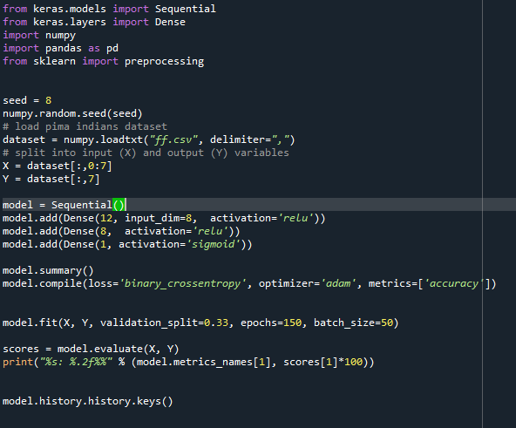

Output:

